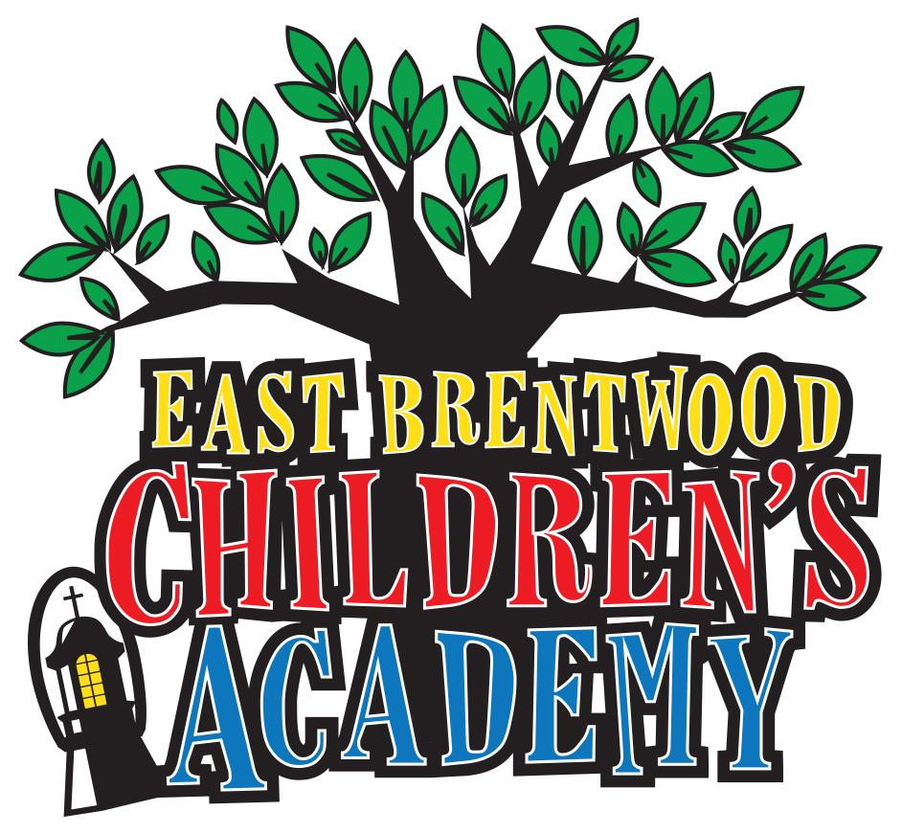

East Brentwood Presbyterian Church Preschool Announces Name Change to East Brentwood Children’s Academy and Marks 20 Year Anniversary

Registration Now Open for 2019 - 2020 Program

BRENTWOOD, Tenn. -- January 11, 2019 -- As it marks 20 years of providing families with an outstanding early educational program, East Brentwood Presbyterian Church Preschool today announced it will become East Brentwood Children’s Academy (EBCA). The school also announced registration is now open for the 2019 - 2020 program.
“For 20 years we have provided children in our community with an exemplary early childhood program and have adapted to their changing educational needs,” said Sheri Vosel, director at East Brentwood Children’s Academy. “Our new name continues to represent our focus to develop the whole child--academic preparation, and emotional and spiritual needs--but is more inclusive of some of our broadening services. We look forward to continuing to partner with families for decades to come and evolve our program while maintaining our standards of early childhood education excellence.”
Established in 1999, and a vital mission of East Brentwood Presbyterian Church, EBCA offers small class sizes for children ages 2-5 years old and prepares children for kindergarten through a wide variety of opportunities, including learning centers, physical activities, free play, art and music and chapel time.
EBCA teachers bring more than 300 years of combined experience in childhood development, and the school has received a three-star for excellence in childcare (the highest rating available in Tennessee) for 20 years. EBCA also led the way in the community with its peanut-free and tree nut-free facility--accommodating for those among many other allergies. Most recently, the school added before and aftercare and is exploring potential enrichment opportunities to complement its program.
“East Brentwood Presbyterian Church Preschool has served the needs of thousands of children through its well-rounded curriculum delivered by a caring team of early childhood educators within a supportive Christian environment,” said John Hilley, pastor at East Brentwood Presbyterian Church.“ As the preschool celebrates 20 years, the name change to East Brentwood Children’s Academy represents the next chapter in its journey to support the ever changing needs of our community. I look forward to continuing our mission to provide a high quality preschool experience as we look at addressing the expanding needs of our increasingly diverse community of families in the Brentwood and Nolensville area.”
EBCA serves children in Williamson County, Southern Davidson County and Eastern Rutherford County. To schedule a tour, please contact the school at: 615-370-4296 or email info@ebchildrensacademy.org. For more information about EBCA and registration, please visit: http://ebchildrensacademy.org
About East Brentwood Children’s Academy
East Brentwood Children’s Academy (EBCA) strives to nurture a child’s early childhood education by providing a Christian environment that promotes school readiness, nurtures curiosity, focuses on the whole child and lays the foundation for character education. EBCA is a vital mission of East Brentwood Presbyterian Church and has been awarded three stars (highest rating available) by the State of Tennessee for excellence in childcare since the program began in 1999.

###

